|  |
| --- |
| 台科大 |
| PA3 |
| 30頁真的寫不完 |

|  |
| --- |
| 周 柏宇  2024/5/20 |

內容

Part 1 1

Adder 1

Description 1

IO 1

Explanation 2

ALU_Control 2

Description 2

IO 2

Explanation 2

ALU 2

Description 2

IO 2

Explanation 3

Control 3

Description 3

IO 3

Explanation 4

DM 4

Description 4

IO 4

Explanation 4

EX_MEM 5

Description 5

IO 5

Explanation 5

GPRMUX 6

Description 6

IO 6

Explanation 6

ID_EX 6

Description 6

IO 6

Explanation 7

IF_ID 8

Description 8

IO 8

Explanation 8

IM 8

Description 8

IO 8

Explanation 8

MEM_WB 8

Description 8

IO 8

Explanation 9

R_PipelineCPU 9

Description 10

IO 10

Explanation 10

RegMUX 11

Description 11

IO 11

Explanation 11

RF 11

Description 11

IO 11

Explanation 11

Part 2 12

Changes 12

Part 3 12

Changes 12

New modules 12

FinalCPU 12

Forwarding_Unit 14

HD_Unit 15

Stall_MUX 15

TMUX 16

Part 1 Test Program 16

RF 16

Part 2 Test Program 16

DM 16

RF 17

Part 3 Test Program 17

DM 17

RF 17

Simulation Result 17

Timing 17

Utilization 17

Power 17

# Part 1

## Adder

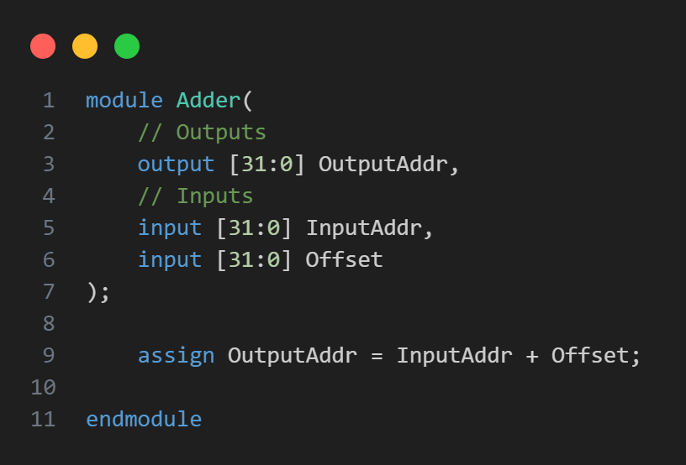

### Description

The purpose of the Adder module isto compute the sum of two 32-bit input values, InputAddr and Offset, and provide the result as a 32-bit output value, OutputAddr.

### IO

Inputs:

|  |  |  |
| --- | --- | --- |
| Port | Width | Description |
| InputAddr | 31 bits | Original pc addr. |
| Offset | 31 bits | How many to be added. |

Outputs:

|  |  |  |
| --- | --- | --- |
| Port | Width | Description |
| OutputAddr | 31 bits | New pc addr. |

### Explanation

line 9

Using assign statement to perform a continuous addition of the inputs in.

## ALU_Control

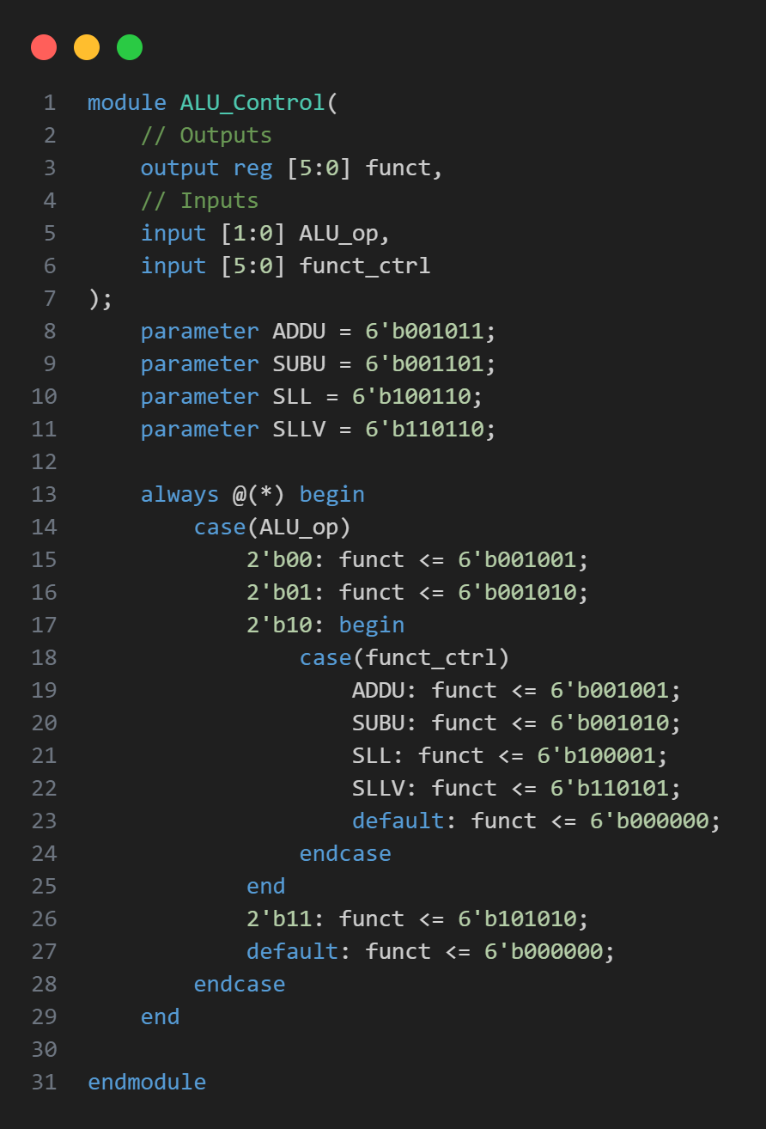

### Description

Generates a function code (**funct**) based on the ALU operation code (**ALU_op**) and a function control code (**funct_ctrl**).

### IO

Input:

|  |  |  |
| --- | --- | --- |
| Port | Width | Description |
| ALU_op | 2 bits | ALU operation code that determines the type of operation. |
| funct_ctrl | 6 bits | Function control code used for specific operations when **ALU_op** is **2'b10**. |

Outputs:

|  |  |  |
| --- | --- | --- |
| Port | Width | Description |
| funct | 6 bits | Function code output used to control the ALU operation. |

### Explanation

* When **ALU_op** is **2'b00**, **funct** is set to **6'b001001**.
* When **ALU_op** is **2'b01**, **funct** is set to **6'b001010**.
* When **ALU_op** is **2'b11**, **funct** is set to **6'b101010**.
* When **ALU_op** is **2'b10**
  + ADDU: funct is set to 6'b001001.
  + SUBU: funct is set to 6'b001010.
  + SLL: funct is set to 6'b100001.
  + SLLV: funct is set to 6'b110101.
  + For any other funct_ctrl value, funct defaults to 6'b000000.

## ALU

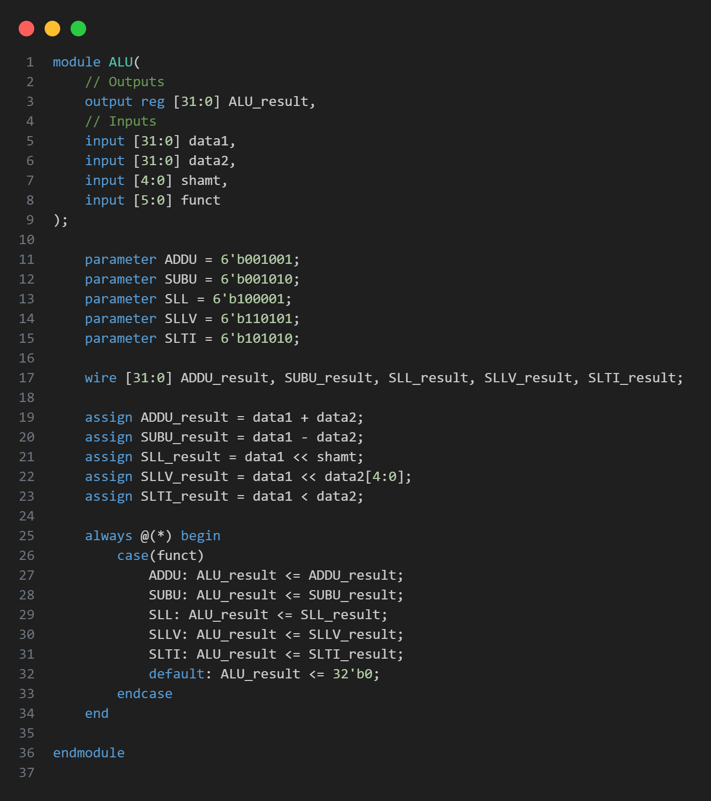

### Description

Performs arithmetic and logical operations based on the function code (**funct**).

### IO

Inputs:

|  |  |  |
| --- | --- | --- |
| Port | Width | Description |
| data1 | 32 bits | First operand for the ALU operation. |
| data2 | 32 bits | Second operand for the ALU operation or shift amount in SLLV. |
| shamt | 5 bits | Shift amount for the shift left logical (SLL) operation. |
| funct | 6 bits | Function code that determines the specific ALU operation to perform. |

Outputs:

|  |  |  |
| --- | --- | --- |
| Port | Width | Description |
| ALU_result | 32 bits | Result of the ALU operation. |

### Explanation

Line 19~23

Using wire to get all result at the same time

Line 25~33

Put the value to ALU_result designated by funct.

## Control

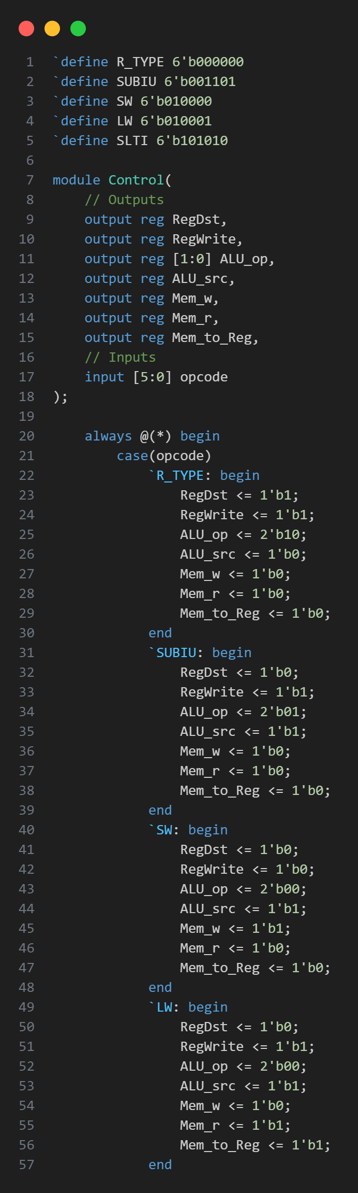

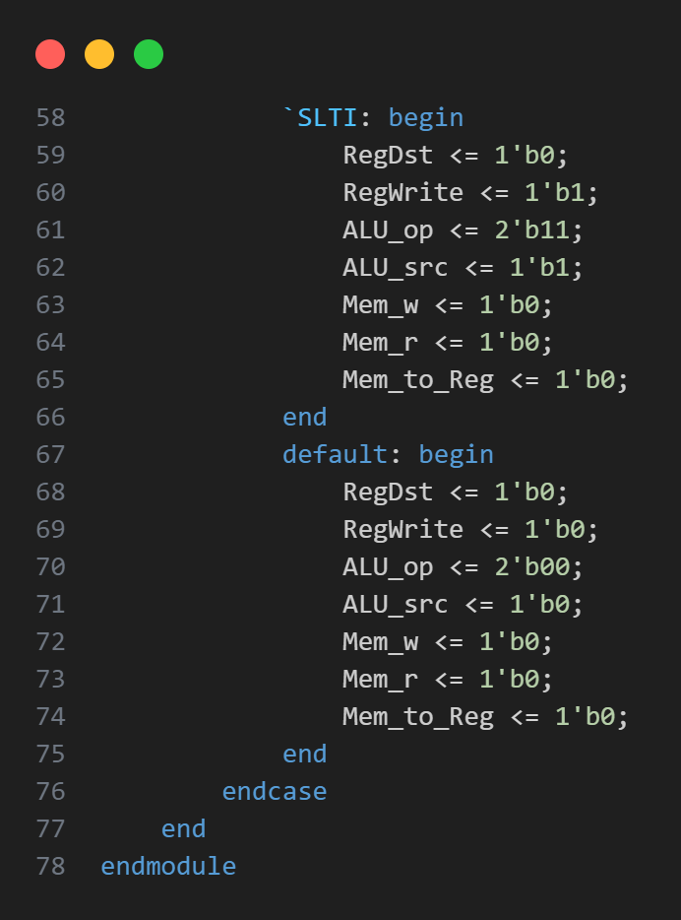

### Description

Generates control signals based on the opcode of an instruction.

### IO

Inputs:

|  |  |  |
| --- | --- | --- |
| Port | Width | Description |
| opcode | 6 bits | Opcode of the instruction to be decoded. |

Outputs:

|  |  |  |
| --- | --- | --- |
| Port | Width | Description |
| RegDst | 1 bit | Determines the destination register for the write operation. |
| RegWrite | 1 bit | Enables writing to the register file. |
| ALU_op | 2 bits | Selects the ALU operation to be performed. |
| ALU_src | 1 bit | Selects the second operand for the ALU. |
| Mem_w | 1 bit | Enables writing to memory. |
| Mem_r | 1 bit | Enables reading from memory. |
| Mem_to_Reg | 1 bit | Selects the data source for writing to the register file. |

### Explanation

uses an **always @(*)** block to generate control signals based on the input **opcode**.

## DM

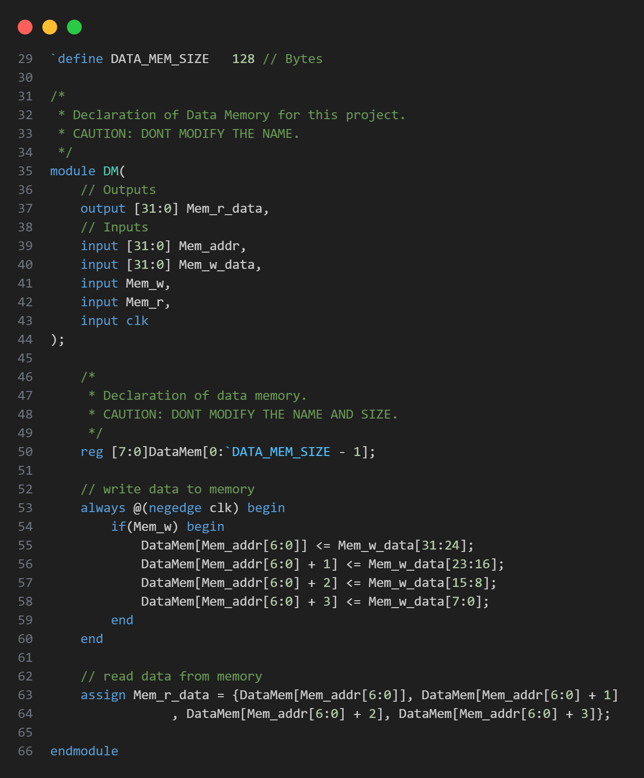

### Description

Simulate a data memory component that allows reading from and writing to memory locations.

Not used in R type.

### IO

Inputs:

|  |  |  |
| --- | --- | --- |
| Port | Width | Description |
| Mem_addr | 32 bits | Address from which to read or write data. |
| Mem_w_data | 32 bits | Data to be written to the memory. |
| Mem_w | 1 bit | Write enable signal; when high, data is written to memory. |
| Mem_r | 1 bit | Read enable signal. Not used in this implementation |
| clk | 1 bit | Clock signal. Not used in this implementation. |

Outputs:

|  |  |  |
| --- | --- | --- |
| Port | Width | Description |
| Mem_r_data | 32 bits | Data read from the memory. |

### Explanation

Using **always @(*)** block ensures that writing occurs whenever **Mem_w** is high.

Using **assign** statement continuously updates **Mem_r_data** based on the current memory contents at the specified address.

## EX_MEM

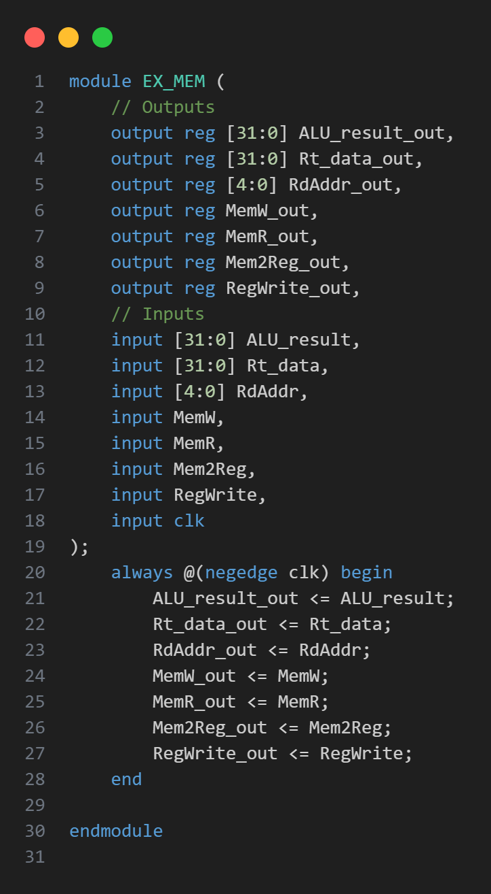

### Description

Stores the outputs from the execution stage and passes them to the memory stage in a pipelined processor.

### IO

Inputs:

|  |  |  |
| --- | --- | --- |
| Port | Width | Description |
| ALU_result | 32 bits | Result of the ALU operation from the execution stage. |
| Rt_data | 32 bits | Data from register **Rt** from the execution stage. |
| RdAddr | 5 bits | Register destination address from the execution stage. |
| MemW | 1 bit | Signal indicating memory write operation. |
| MemR | 1 bit | Signal indicating memory read operation. |
| Mem2Reg | 1 bit | Signal indicating whether memory data should be written back to a register. |
| RegWrite | 1 bit | Signal enabling register write operation. |
| clk | 1 bit | Clock signal. |

Outputs:

|  |  |  |
| --- | --- | --- |
| Port | Width | Description |
| ALU_result_out | 32 bits | Result of the ALU operation. |
| Rt_data_out | 32 bits | Data from register **Rt**. |
| RdAddr_out | 5 bits | Register destination address for write-back. |
| MemW_out | 1 bit | Signal indicating memory write operation. |
| MemR_out | 1 bit | Signal indicating memory read operation. |
| Mem2Reg_out | 1 bit | Signal indicating whether memory data is written back to a register. |
| RegWrite_out | 1 bit | Signal enabling register write operation. |

### Explanation

Use registers to store the results and control signals from the EX stage on the falling edge of the clock.

## GPRMUX

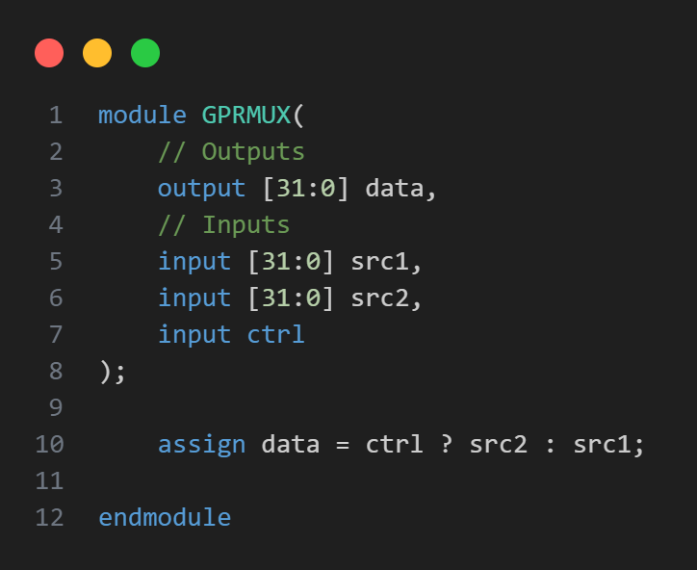

### Description

2-to-1 multiplexer that selects one of two 32-bit input data signals based on a control signal.

### IO

Inputs:

|  |  |  |
| --- | --- | --- |
| Port | Width | Description |
| src1 | 32 bits | First input data. |
| src2 | 32 bits | Second input data. |
| ctrl | 1 bit | Control signal to select between **src1** and **src2**. |

Outputs:

|  |  |  |
| --- | --- | --- |
| Port | Width | Description |
| data | 32 bits | Selected output data based on control signal. |

### Explanation

* When **ctrl** is **0**, the output **data** is equal to **src1**.
* When **ctrl** is **1**, the output **data** is equal to **src2**.

## ID_EX

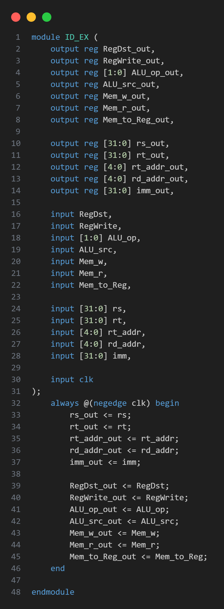

### Description

Stores intermediate values and control signals between the Instruction Decode (ID) stage and the Execution (EX) stage.

### IO

Inputs:

|  |  |  |
| --- | --- | --- |
| Port | Width | Description |
| RegDst | 1 bit | Control signal selecting the destination |
| RegWrite | 1 bit | Control signal enabling the register write operation. |
| ALU_op | 2 bits | Control signals for ALU operation type. |
| ALU_src | 1 bit | Control signal selecting the ALU source operand. |
| Mem_w | 1 bit | Control signal enabling memory write operation. |
| Mem_r | 1 bit | Control signal enabling memory read operation. |
| Mem_to_Reg | 1 bit | Control signal for selecting data source to write back to the register. |
| rs | 32 bits | Data from source register **rs**. |
| rt | 32 bits | Data from source register **rt**. |
| rt_addr | 5 bits | Address of the **rt** register. |
| rd_addr | 5 bits | Address of the **rd** register. |
| imm | 32 bits | Immediate value. |
| clk | 1 bit | Clock signal. |

Outputs:

|  |  |  |
| --- | --- | --- |
| Port | Width | Description |
| RegDst_out | 1 bit | Output control signal selecting the desination. |
| RegWrite_out | 1 bit | Output control signal enabling the register write operation. |
| ALU_op_out | 2 bits | Output control signals for ALU operation type. |
| ALU_src_out | 1 bit | Output control signal selecting the ALU source operand. |
| Mem_w_out | 1 bit | Output control signal enabling memory write operation. |
| Mem_r_out | 1 bit | Output control signal enabling memory read operation. |
| Mem_to_Reg_out | 1 bit | Output control signal for selecting data source to write back to the register. |
| rs_out | 32 bits | Output data from source register **rs**. |
| rt_out | 32 bits | Output data from source register **rt**. |
| rt_addr_out | 5 bits | Output address of the **rt** register. |
| rd_addr_out | 5 bits | Output address of the **rd** register. |
| imm_out | 32 bits | Output immediate value. |

### Explanation

On the falling edge of the clock, the module transfers the input data and control signals to their respective output ports.

## IF_ID

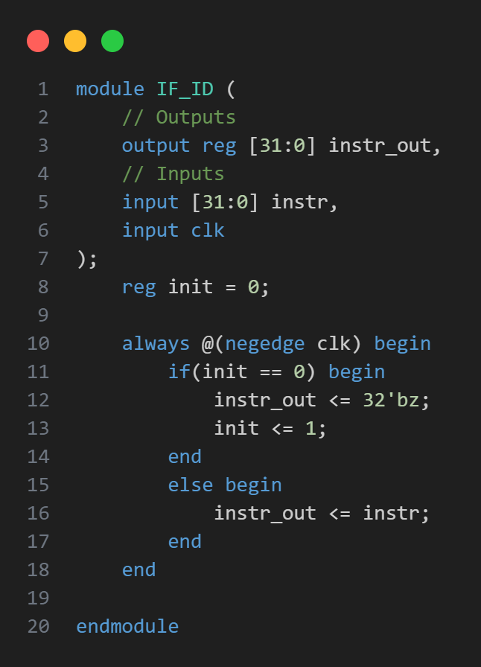

### Description

Captures and holds the instruction fetched from the instruction memory in the Instruction Fetch (IF) stage.

### IO

Inputs:

|  |  |  |
| --- | --- | --- |
| Port | Width | Description |
| instr | 32 bits | Input instruction from the instruction memory. |
| clk | 1 bit | Clock signal. |

Outputs:

|  |  |  |
| --- | --- | --- |
| Port | Width | Description |
| instr_out | 32 bits | Output instruction to be sent to the ID stage. |

### Explanation

Captures the **instr** input on the falling edge of the clock and updates the **instr_out** output with this value.

Using init reg to manually deal with **WRONG** input for the specific case in this PA.

## IM

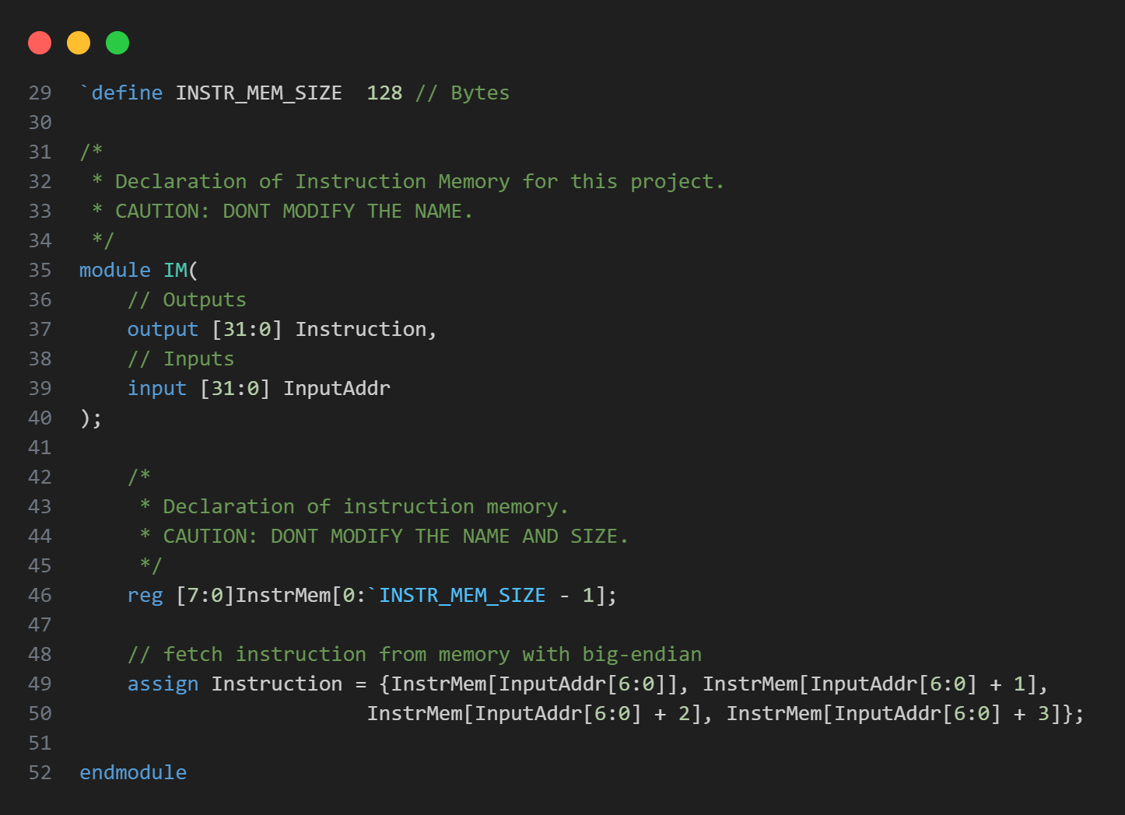

### Description

Fetches 32-bit instructions from memory based on a given input address.

### IO

Inputs:

|  |  |  |
| --- | --- | --- |
| Port | Width | Description |
| InputAddr | 32 bits | Input address used to fetch the instruction from memory. |

Outputs:

|  |  |  |
| --- | --- | --- |
| Port | Width | Description |
| Instruction | 32 bits | Output instruction fetched from memory. |

### Explanation

Concatenates four bytes from the memory array (big endian) to form a 32-bit instruction.

## MEM_WB

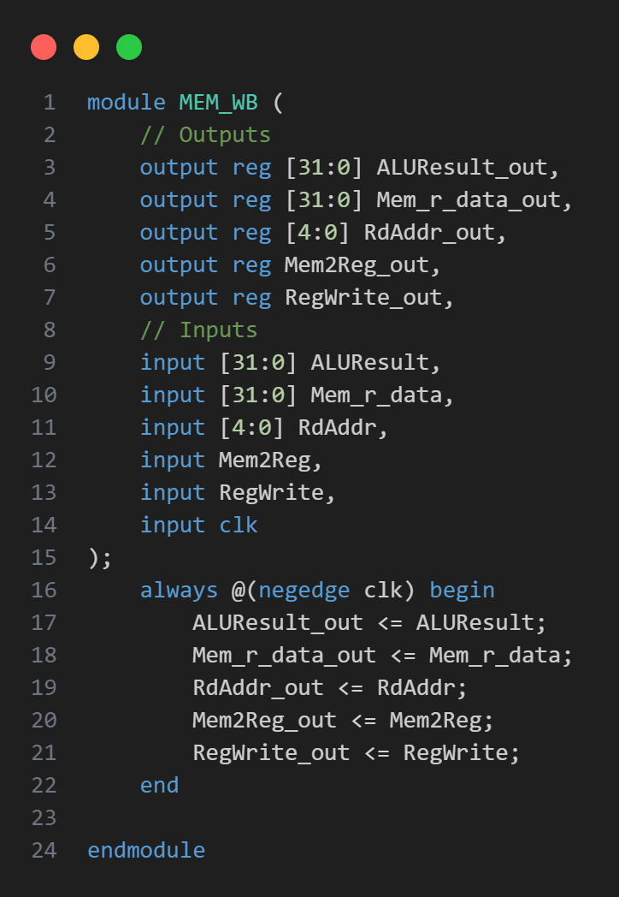

### Description

Hold the data and control signals between the Memory (MEM) stage and the Write-Back (WB) stage.

### IO

Inputs:

|  |  |  |
| --- | --- | --- |
| Port | Width | Description |
| ALUResult | 32 bits | Input result from the ALU. |
| Mem_r_data | 32 bits | Input data read from memory. |
| RdAddr | 5 bits | Input address of the destination register. |
| Mem2Reg | 1 bit | Input control signal for memory to register write. |
| RegWrite | 1 bit | Input control signal enabling the register write. |
| clk | 1 bit | Clock signal. |

Outputs:

|  |  |  |
| --- | --- | --- |
| Port | Width | Description |
| ALUResult_out | 32 bits | Output result from the ALU to be used in the WB stage. |
| Mem_r_data_out | 32 bits | Output data read from memory to be used in the WB stage. |
| RdAddr_out | 5 bits | Output address of the destination register. |
| Mem2Reg_out | 1 bit | Output control signal for memory to register write. |
| RegWrite_out | 1 bit | Output control signal enabling the register write. |

### Explanation

Holds the input values and control signals on the falling edge of the clock (**negedge clk**).

## R_PipelineCPU

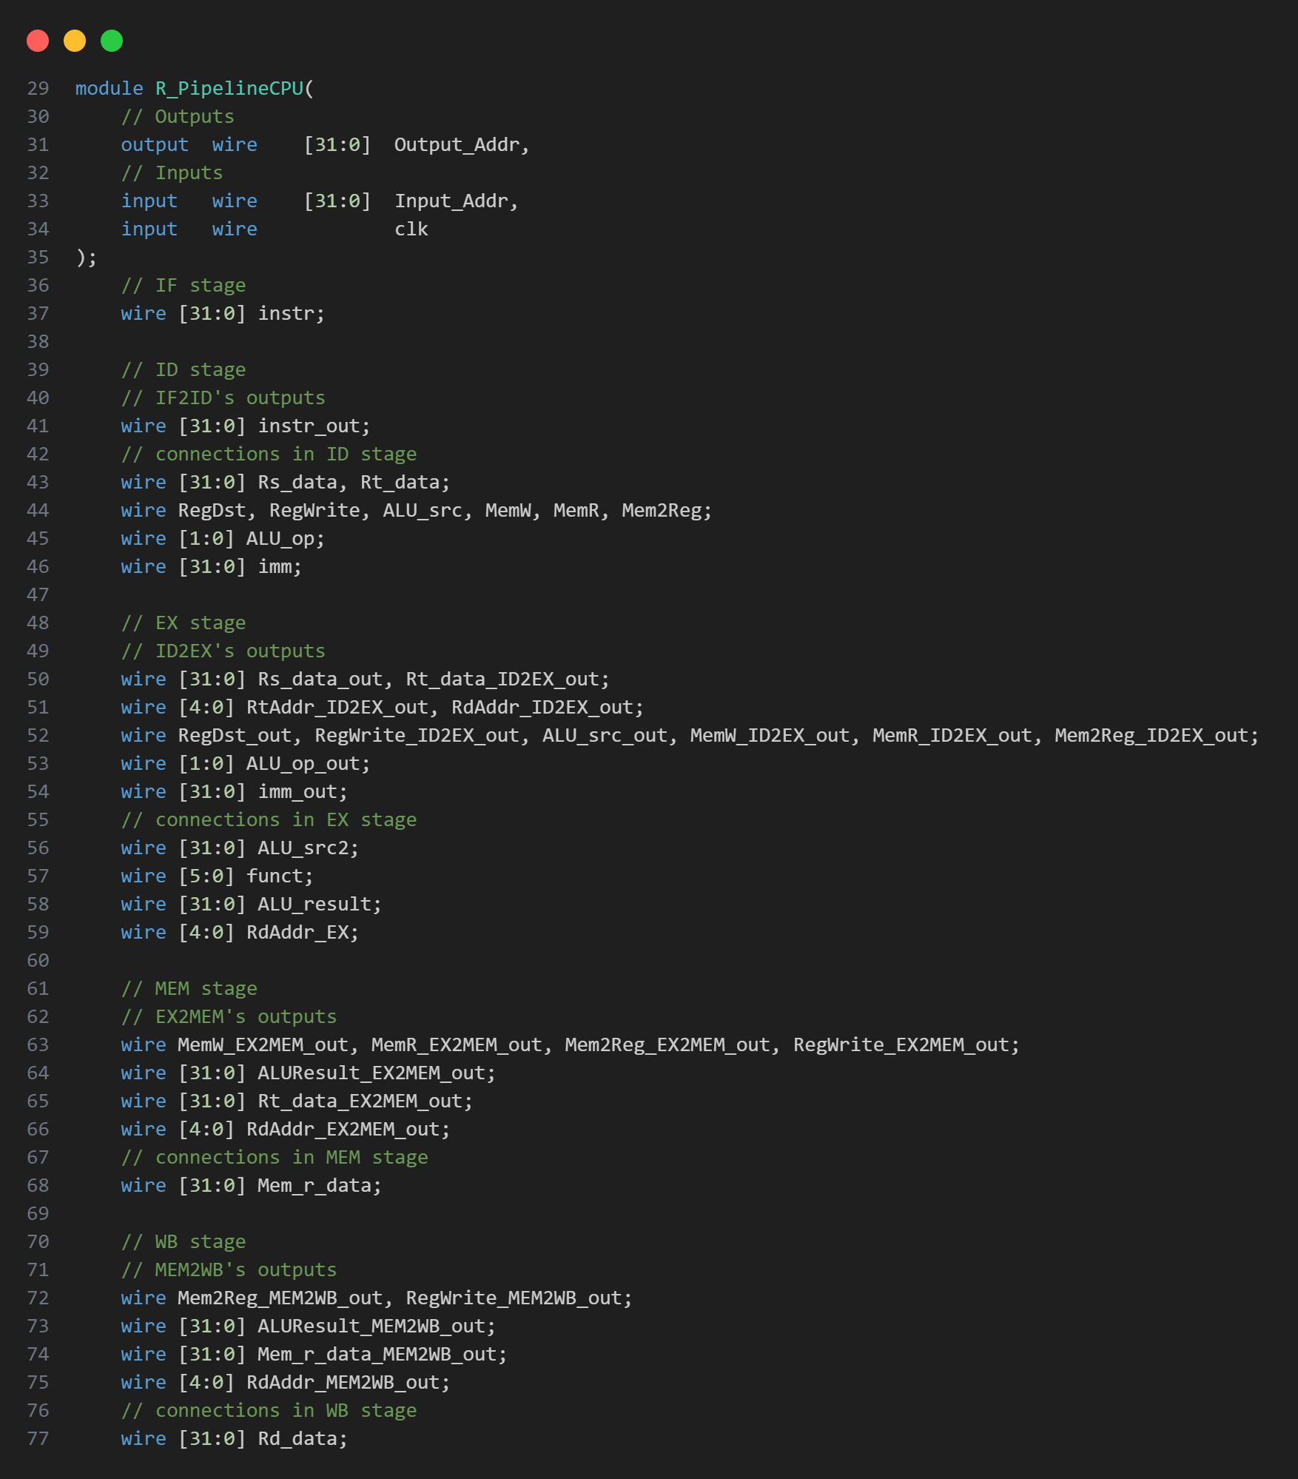

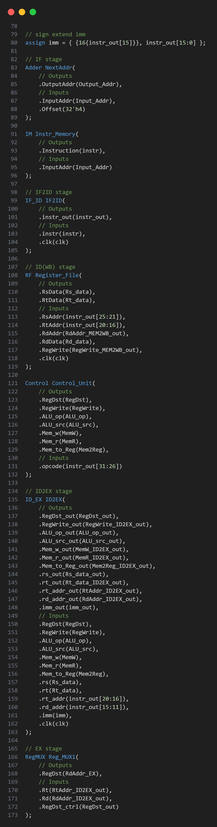

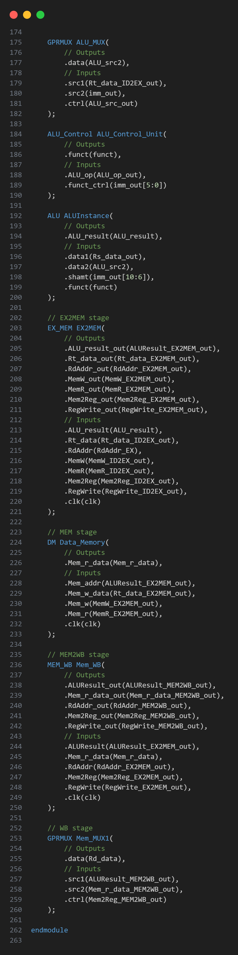

### Description

A pipelined CPU architecture with five pipeline stages: Instruction Fetch (IF), Instruction Decode (ID), Execute (EX), Memory (MEM), and Write-Back (WB)

### IO

Inputs:

|  |  |  |
| --- | --- | --- |
| Port | Width | Description |
| Input_Addr | 32 | PC |
| clk | 1 | Clock signal |

Outputs:

|  |  |  |
| --- | --- | --- |
| Port | Width | Description |
| Output_Addr | 32 | PC + 4 |

### Explanation

Line 36~77

Wires that connecting the components. They are sorted by their corresponding stage.

Line 78~

Components’ instances. They are mostly sorted by their corresponding stage.

Each pipeline stage has its corresponding registers (**IF_ID**, **ID_EX**, **EX_MEM**, **MEM_WB**) to store intermediate results and control signals between pipeline stages.

## RegMUX

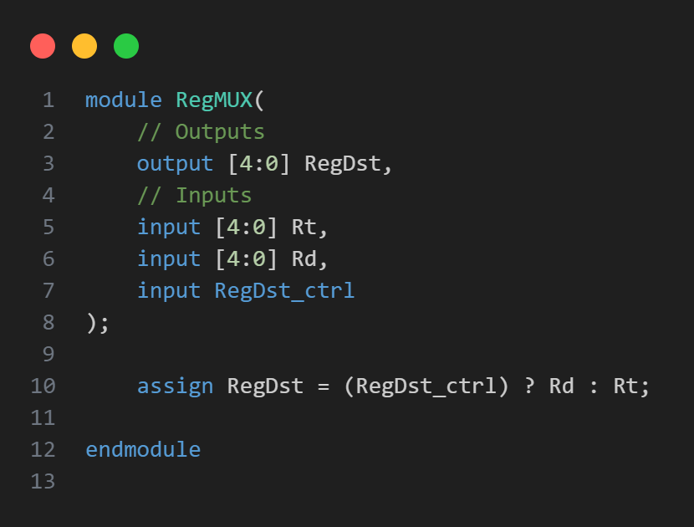

### Description

For selecting the destination register address.

### IO

Inputs:

|  |  |  |
| --- | --- | --- |
| Port | Width | Description |
| Rt | 5 bits | Input register address representing the source register. |
| Rd | 5 bits | Input register address representing the destination register. |
| RegDst_ctrl | 1 bit | Input control signal for selecting the destination register. |

Outputs:

|  |  |  |
| --- | --- | --- |
| Port | Width | Description |
| RegDst | 5 bits | Output selected register address. |

### Explanation

Using RegDst_ctrl to selects either the source register address (**Rt**) or the destination register address (**Rd**) as the output.

## RF

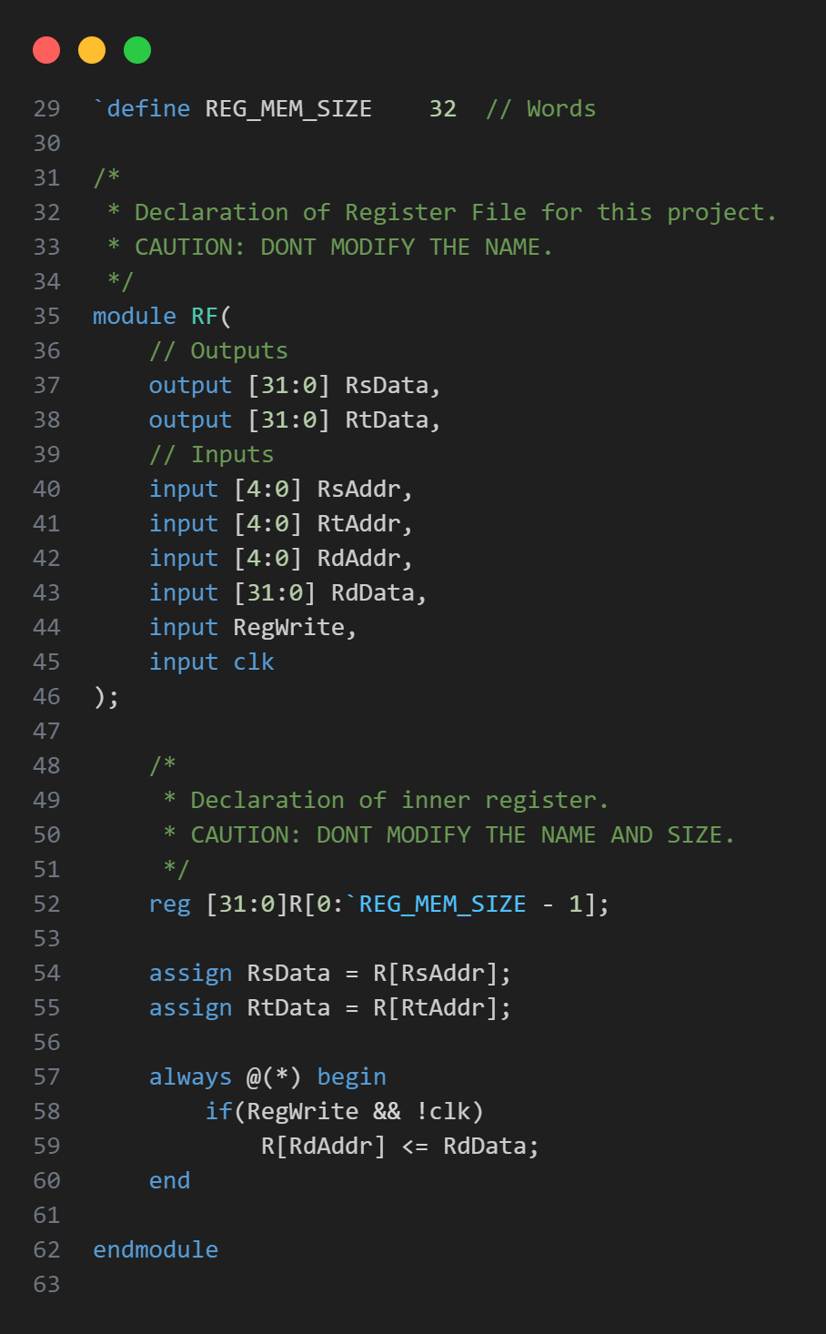

### Description

Register file.

### IO

Inputs:

|  |  |  |
| --- | --- | --- |
| Port | Width | Description |
| RsAddr | 5 bits | Input address for reading data from the register file (**RsData**). |
| RtAddr | 5 bits | Input address for reading data from the register file (**RtData**). |
| RdAddr | 5 bits | Input address for writing data to the register file. |
| RdData | 32 bits | Input data to be written to the register specified by **RdAddr**. |
| RegWrite | 1 bit | Input control signal for enabling register write. |
| clk | 1 bit | Clock signal. |

Outputs:

|  |  |  |
| --- | --- | --- |
| Port | Width | Description |
| RsData | 32 bits | Output data from the register specified by **RsAddr**. |
| RtData | 32 bits | Output data from the register specified by **RtAddr**. |

### Explanation

* Constantly read data
* Write only when **RegWrite** is asserted and **clk** is deasserted.

# Part 2

## Changes

It’s the same as Part 1. Except “R_PipelineCPU” is renamed to “I_PipelineCPU.”

# Part 3

## Changes

1. Rename “GPRMUX” to “DMUX” which stands for double sources mux.
2. Rename RegMUX’s input addresses as addr1 and addr2 respectively for more accurate discription.
3. “ID_EX” add **rs_addr** as input and **rs_addr_out** as output for detecting data hazard.

## New modules

### FinalCPU

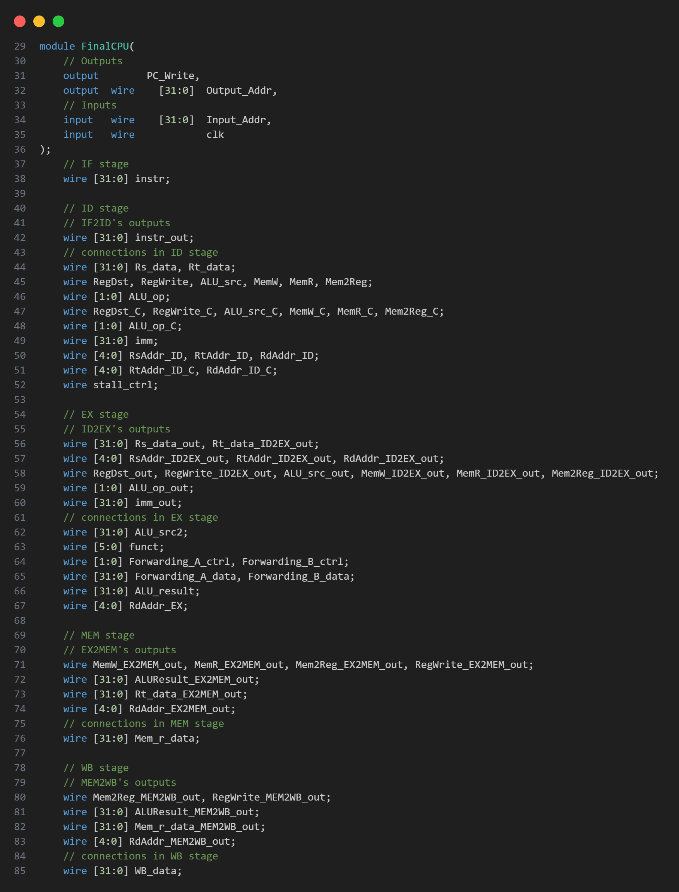

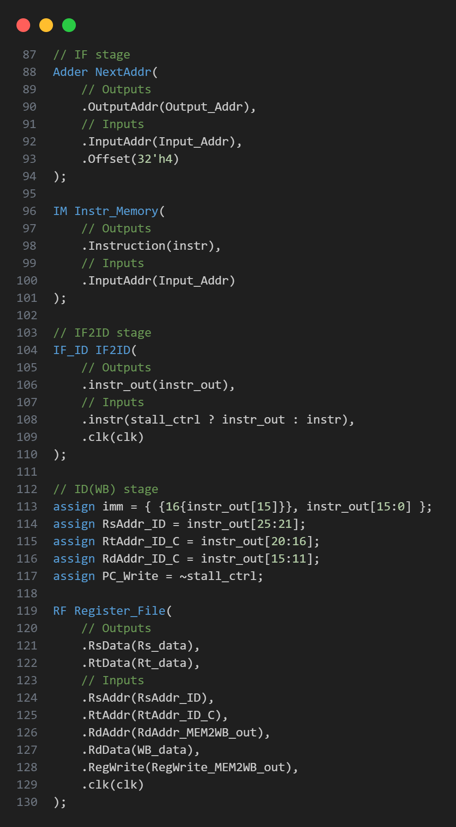

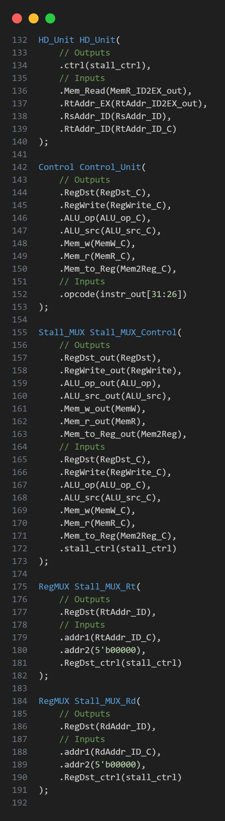

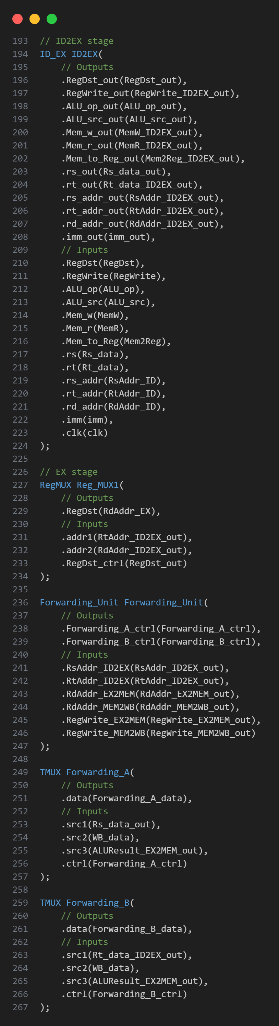

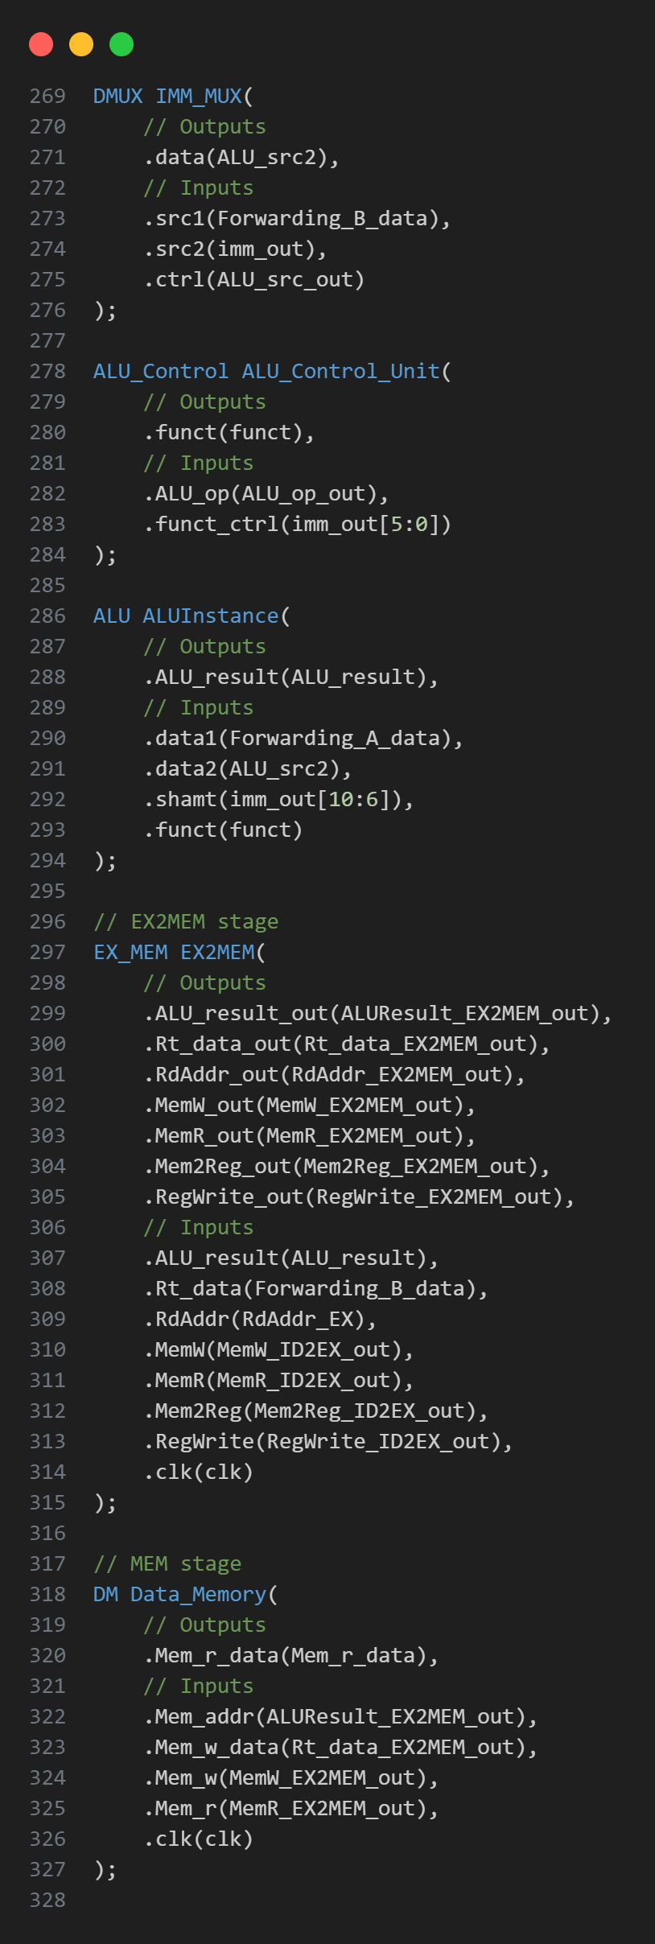

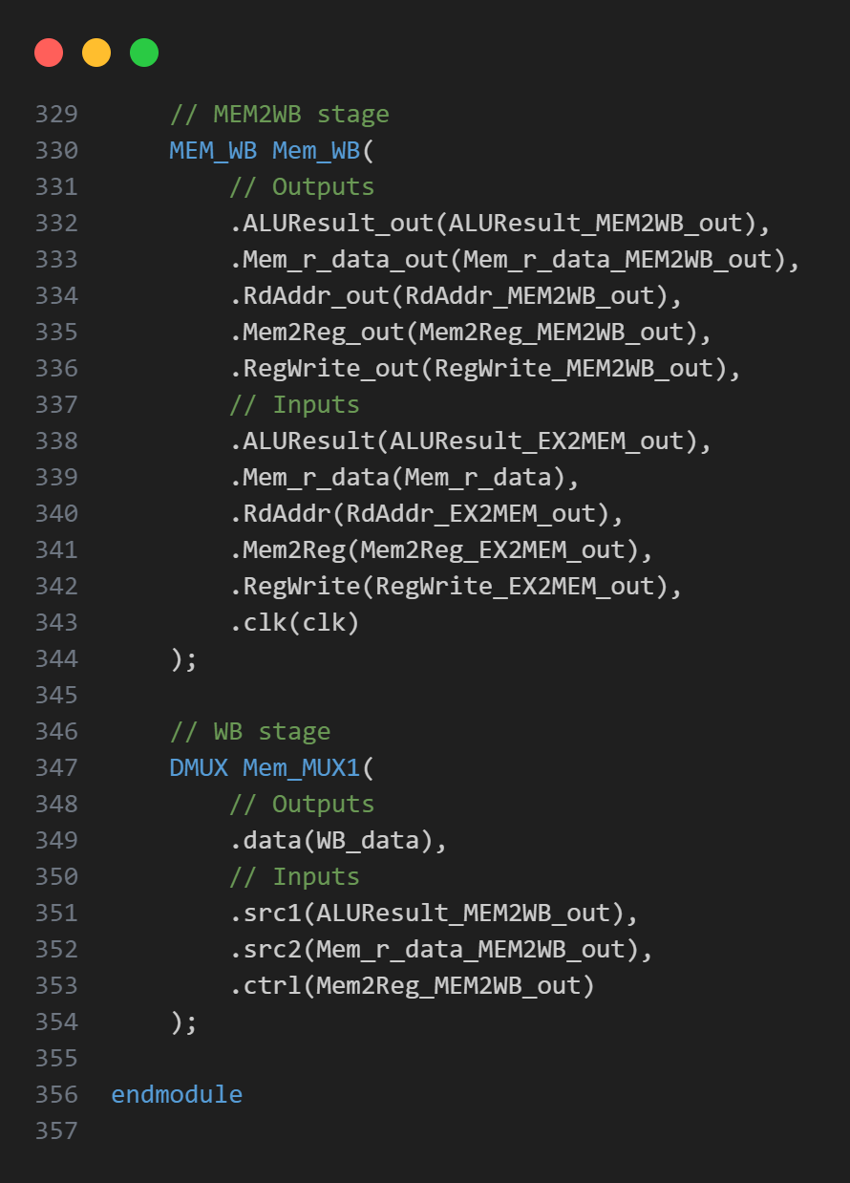

#### Description

A pipelined CPU architecture with five pipeline stages: Instruction Fetch (IF), Instruction Decode (ID), Execute (EX), Memory (MEM), and Write-Back (WB)

#### IO

Inputs:

|  |  |  |
| --- | --- | --- |
| Port | Width | Description |
| Input_Addr | 32 | PC |
| clk | 1 | Clock signal |

Outputs:

|  |  |  |
| --- | --- | --- |
| Port | Width | Description |
| PC_Write | 1 | ~stall |
| Output_Addr | 32 | PC + 4 |

#### Explanation

Line 37~85

Wires that connecting the components. They are sorted by their corresponding stage.

Line 86~

Components’ instances. They are mostly sorted by their corresponding stage.

Each pipeline stage has its corresponding registers (**IF_ID**, **ID_EX**, **EX_MEM**, **MEM_WB**) to store intermediate results and control signals between pipeline stages.

Comparing to previous CPUs, this one uses data forwarding and stall to avoid data hazard.

### Forwarding_Unit

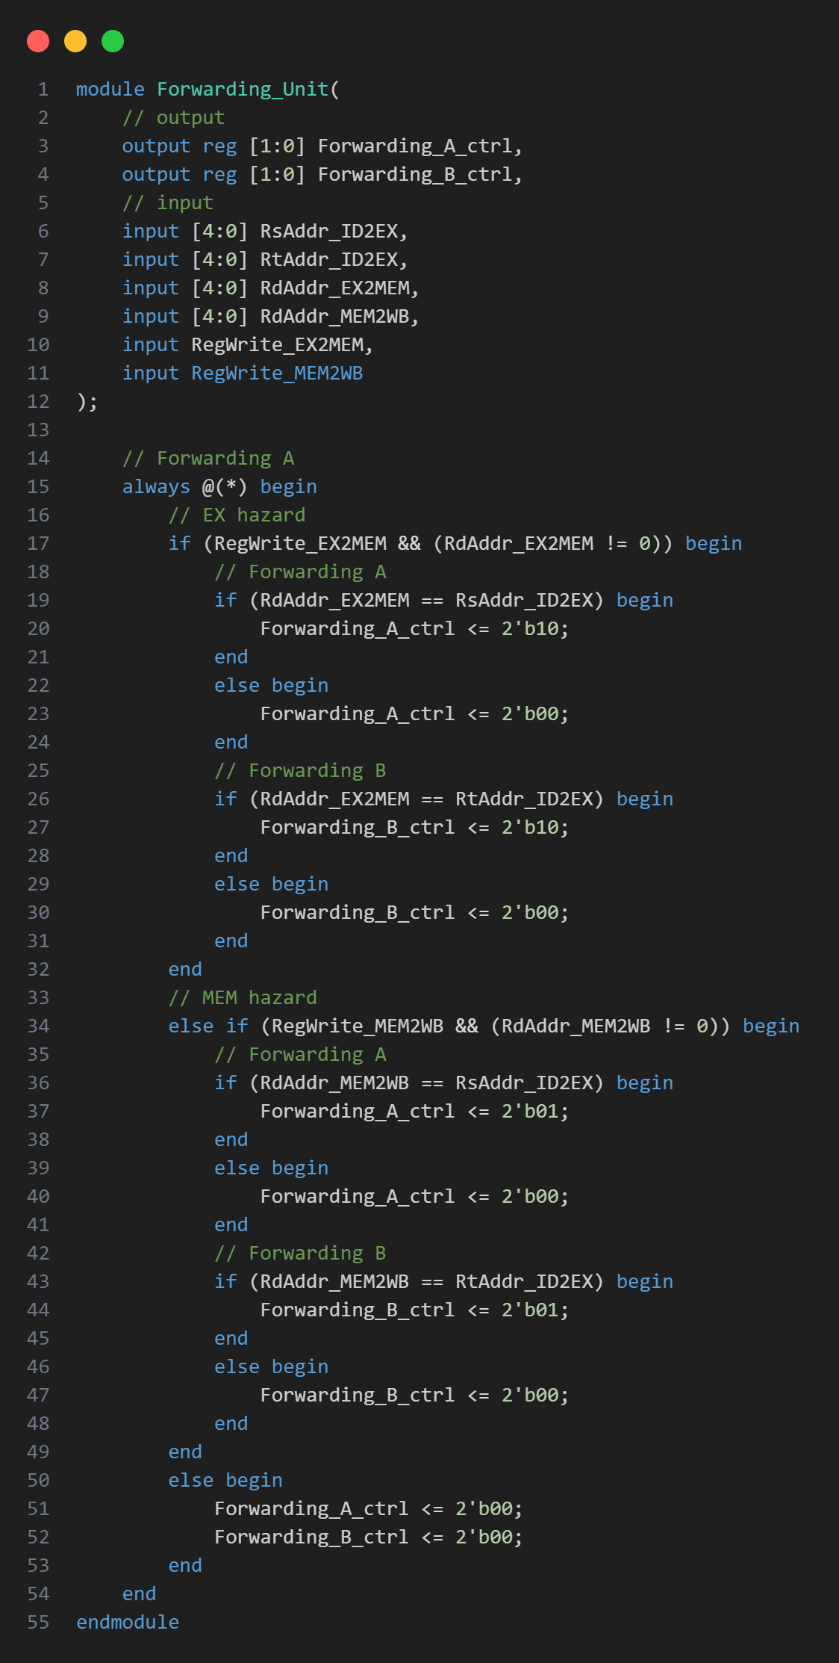

#### Description

generates control signals (**Forwarding_A_ctrl** and **Forwarding_B_ctrl**) to indicate whether to forward data from the execution stage or memory stage to the instruction EX stage.

#### IO

Inputs:

|  |  |  |
| --- | --- | --- |
| Port | Width | Description |
| RsAddr_ID2EX | 5 bits | Input address of source register (**Rs**) in the instruction decode/execute stage. |
| RtAddr_ID2EX | 5 bits | Input address of target register (**Rt**) in the instruction decode/execute stage. |
| RdAddr_EX2MEM | 5 bits | Input address of destination register (**Rd**) in the execution stage. |
| RdAddr_MEM2WB | 5 bits | Input address of destination register (**Rd**) in the memory stage. |
| RegWrite_EX2MEM | 1 bit | Input control signal indicating register write in the MEM stage. |
| RegWrite_MEM2WB | 1 bit | Input control signal indicating register write in the WB stage. |

Outputs:

|  |  |  |
| --- | --- | --- |
| Port | Width | Description |
| Forwarding_A_ctrl | 2 bits | Output control signal for forwarding data to operand A in the instruction EX stage. |
| Forwarding_B_ctrl | 2 bits | Output control signal for forwarding data to operand B in the instruction EX stage. |

#### Explanation

Detects data hazards by comparing the destination register addresses.

* ID/EX: no forwarding, just from the register file (00)
* EX/MEM: forwarded data from the prior ALU results (10)
* MEM/WB: from data memory or an earlier ALU result (01)

### HD_Unit

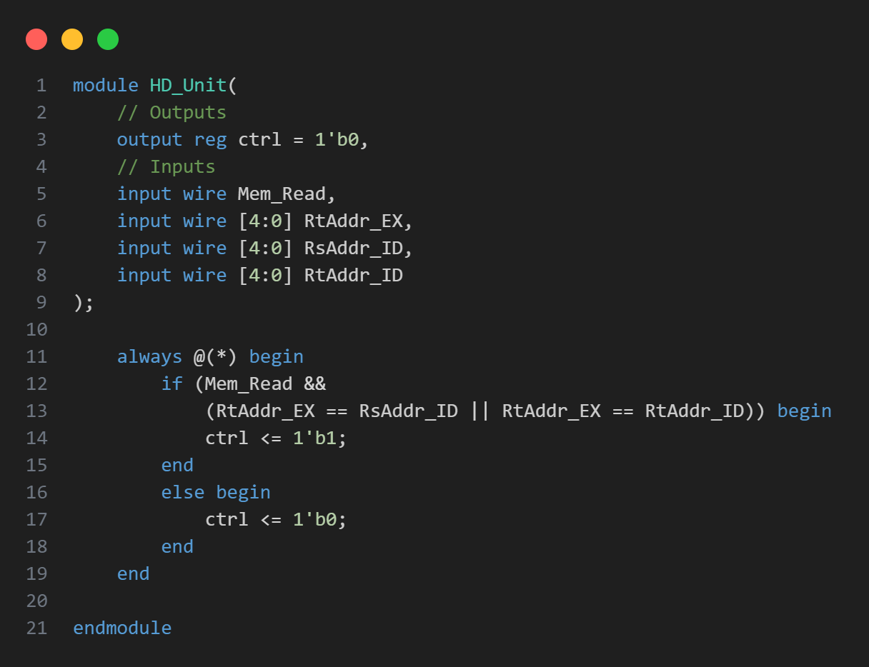

#### Description

Hazard Detection Unit identifies the hazard that cannot be solved by data forwarding.

#### IO

Inputs:

|  |  |  |
| --- | --- | --- |
| Port | Width | Description |
| Mem_Read | 1 bit | Input signal indicating a memory read operation in the EX stage. |
| RtAddr_EX | 5 bits | Input address of the target register (**Rt**) in the execution stage (**EX**). |
| RsAddr_ID | 5 bits | Input address of the source register (**Rs**) in the instruction decode stage (**ID**). |
| RtAddr_ID | 5 bits | Input address of the target register (**Rt**) in the instruction decode stage (**ID**). |

Outputs:

|  |  |  |
| --- | --- | --- |
| Port | Width | Description |
| ctrl | 1 bit | Output control signal indicating the presence of a hazard. |

#### Explanation

Sets the control signal (**ctrl**) to indicate the presence of a hazard, enabling stall operation.

### Stall_MUX

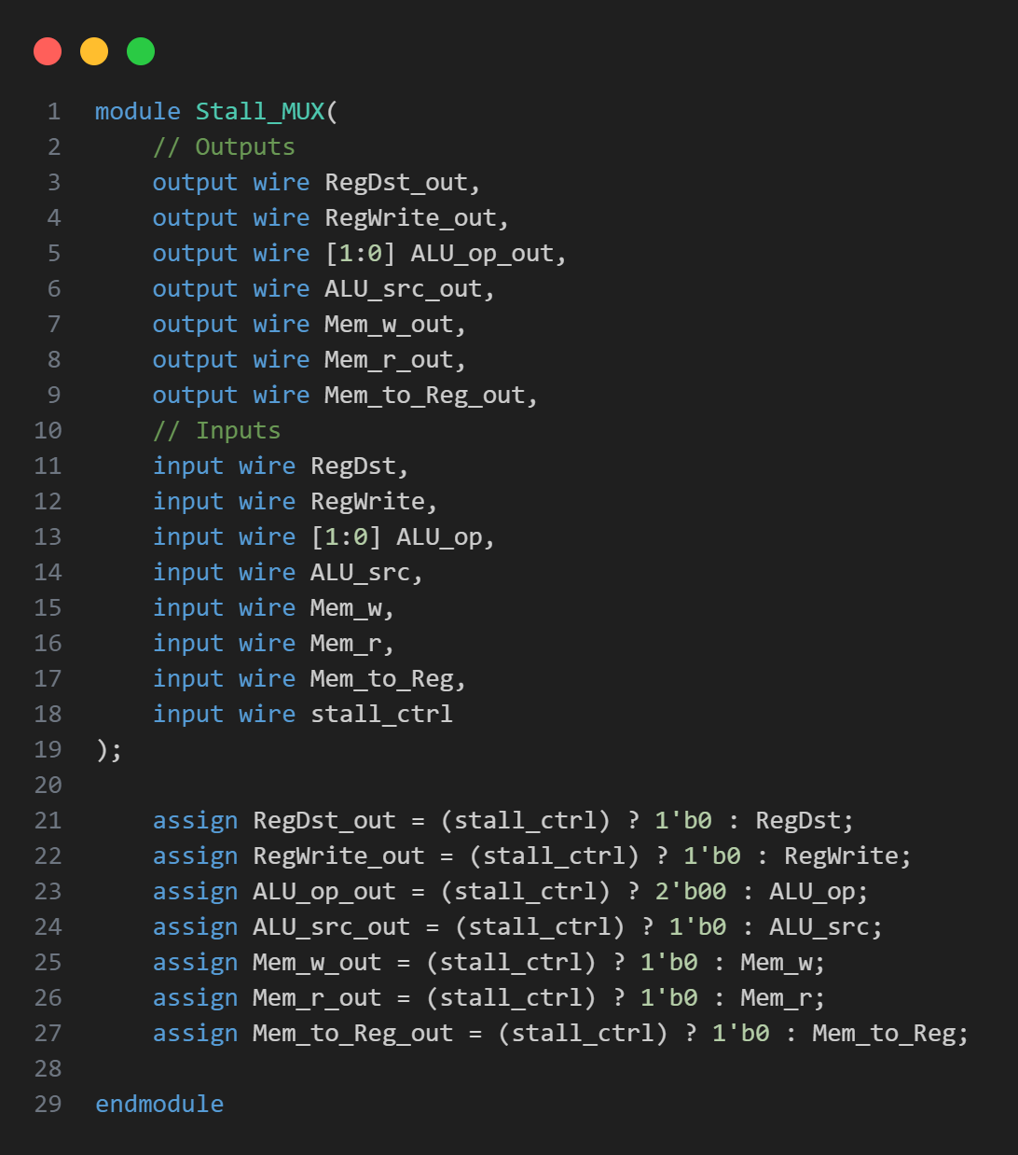

#### Description

Control multiplexer outputs based on a stall control signal (**stall_ctrl**)

#### IO

Inputs:

All outputs of Control

Outputs:

Control signals that have the same amount to Control’s output.

#### Explanation

Utilizes **assign** statements to control the outputs of multiplexers based on the stall control signal (**stall_ctrl**). When a stall is required, all outputs are forced to a default state.

### TMUX

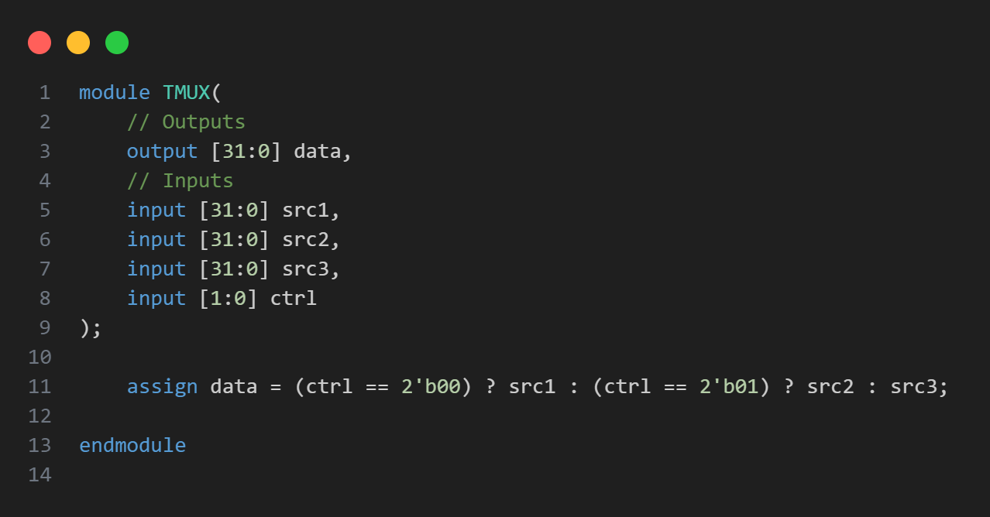

#### Description

Triple MUX. Selecting among 3 sources.

#### IO

Inputs:

|  |  |  |
| --- | --- | --- |
| Port | Width | Description |
| src1 | 32 bits | Input data source 1. |
| src2 | 32 bits | Input data source 2. |
| src3 | 32 bits | Input data source 3. |
| ctrl | 2 bits | Control signal determining the selected input data source. |

Outputs:

|  |  |  |
| --- | --- | --- |
| Port | Width | Description |
| data | 32 bits | Output data resulting from the multiplexing operation. |

#### Explanation

* ctrl == 0, select src1
* ctrl == 1, select src2
* ctrl == 2, select src3

# Part 1 Test Program

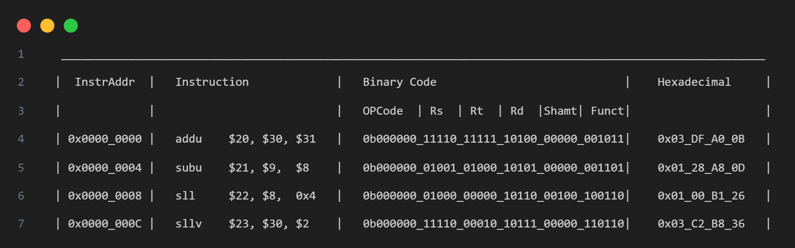

1. R[20]=R[30]+R[31]=FFFF_FF00+ FFFF_FFFF=FFFF_FEFF
2. R[21]=R[9]-R[8]=0000_FFFF- FFFF_0000=0001_FFFF
3. R[22]=R[8]<<shamt=FFFF_0000<<4=FFF0_0000
4. R[23]=R[30]<<R[2][4:0]=FFFF_FF00<<02=FFFF_FC00

## RF

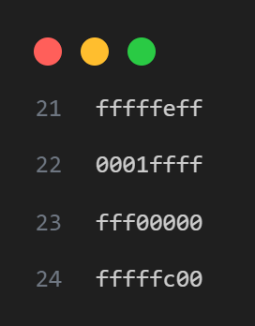

# Part 2 Test Program

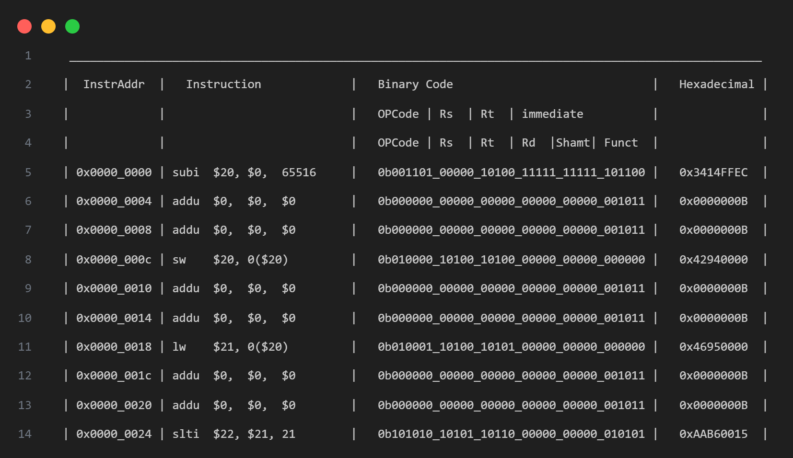

1. R[20]=R[0]-65516=0+0x14=0x14
2. R[0]=R[0]+R[0]=0+0=0, dummy op for avoiding data hazard.
3. R[0]=R[0]+R[0]=0+0=0
4. Mem[0+R[20]]=Mem[0x14]=$20=0x14
5. R[0]=R[0]+R[0]=0+0=0
6. R[0]=R[0]+R[0]=0+0=0
7. R[21]=Mem[0+R[20]]=Mem[0x14]=0x14
8. R[0]=R[0]+R[0]=0+0=0
9. R[0]=R[0]+R[0]=0+0=0
10. R[22]=(R[21]<21)?1:0=1

## DM

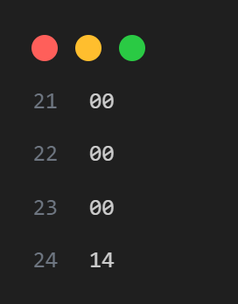

## RF

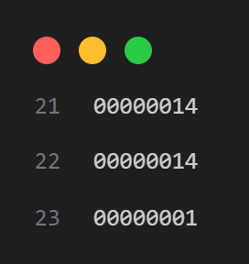

# Part 3 Test Program

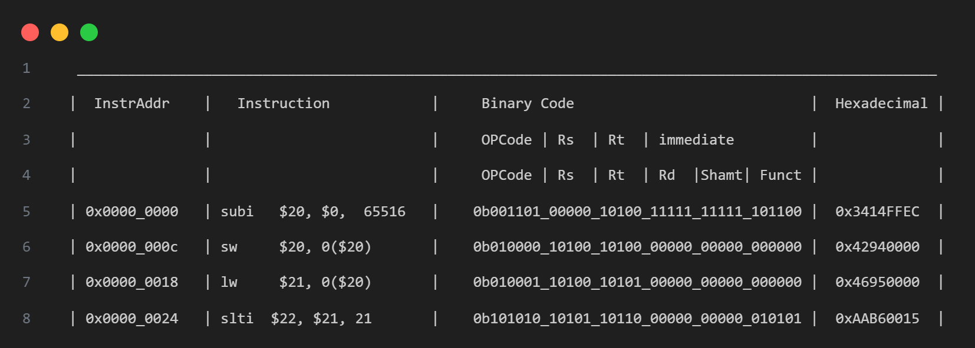

1. R[20]=R[0]-65516=0+0x14=0x14
2. Mem[0+R[20]]=Mem[0x14]=$20=0x14
3. R[21]=Mem[0+R[20]]=Mem[0x14]=0x14
4. R[22]=(R[21]<21)?1:0=1

## DM



## RF



# Simulation Result

## Timing

Clock period = 6.375 ns

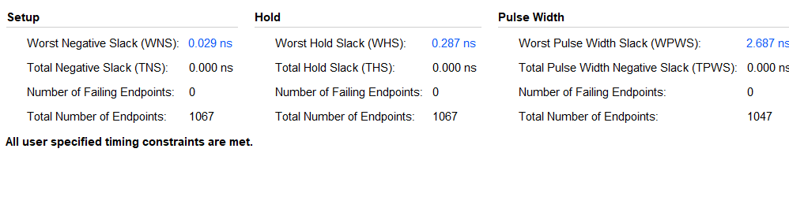

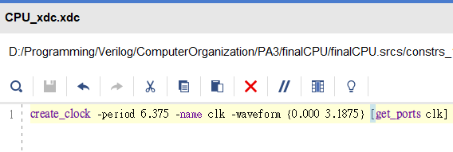

## Utilization

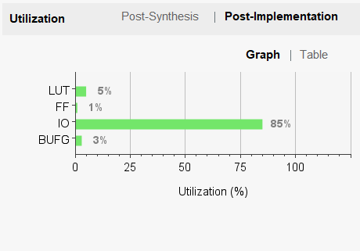

## Power

